UAT Results — Procash Transactions (App 212, Accounts Payable)
Round 1 · 17-Aug-2026 · executed by the automated UAT runner
Scope: manual payments pushed through the bank portal directly, outside Fusion Payables — capture, budget coding, submit and process, reconciliation to the Fusion payable invoice, attachments, export and reporting.
22 of 22 cases passed.

Summary by area
Area | Cases | Passed
Navigation | 1 | 1
Register | 2 | 2
Capture | 1 | 1
Validation | 2 | 2
Budget coding | 3 | 3
Lifecycle | 3 | 3
Reconciliation | 3 | 3
Controls | 1 | 1
Audit | 1 | 1
Attachments | 1 | 1
Export | 1 | 1
Reporting | 1 | 1
Localisation | 1 | 1
Excel | 1 | 1

Cases

01 · Open the Procash Transactions register
Area: Navigation
Steps: Sign in to the AP app and choose Procash Transactions in the side navigation.
Expected: The register page opens with its title, filter bar and results region.
Actual: Page title: "Procash Transactions"
Status: PASS
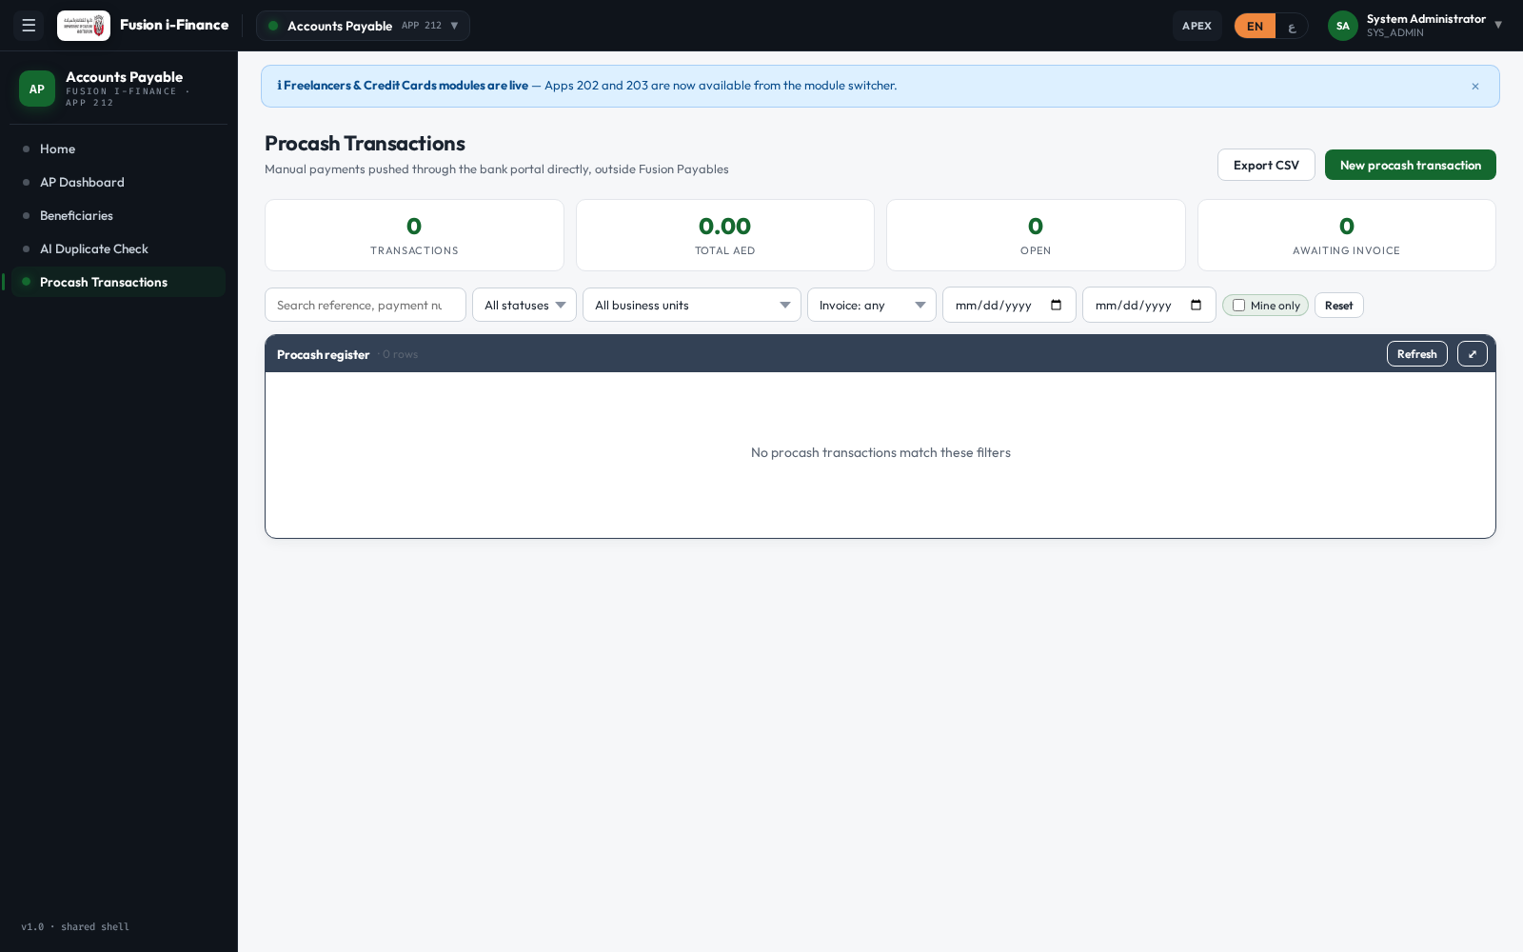

02 · The KPI band summarises the filtered set
Area: Register
Steps: Look at the band above the filters.
Expected: Four tiles: transactions, total AED, open, awaiting invoice.
Actual: 4 KPI tiles rendered
Status: PASS


03 · Record a new procash payment
Area: Capture
Steps: Choose New procash transaction, enter the bank reference, paying account, payee, business unit and amount, then Save.
Expected: The payment is saved as a Draft and the system stamps a payment number (PCH-#####).
Actual: Title after save: "Procash PCH-00030"
Status: PASS
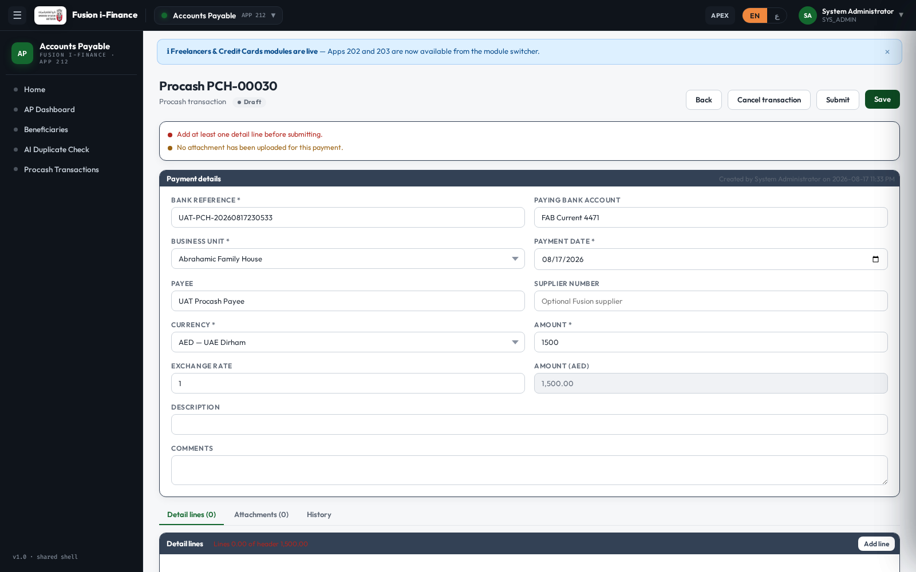

04 · An unfinished payment says what is missing
Area: Validation
Steps: Look at the message band under the page header.
Expected: A blocking finding tells the user a detail line is still required.
Actual: 1 blocking finding(s) shown
Status: PASS


05 · The same bank reference cannot be recorded twice
Area: Validation
Steps: Try to save a second payment carrying a bank reference already on file.
Expected: The system refuses it (400) and explains that the reference is already recorded.
Actual: HTTP 400 returned
Status: PASS

06 · Code a detail line to a project, task and expenditure type
Area: Budget coding
Steps: Open Add line, choose the coding basis Project, pick the project, task and expenditure type, enter the amount and Save.
Expected: The line is stored and appears in the detail grid.
Actual: 1 detail line(s) listed
Status: PASS
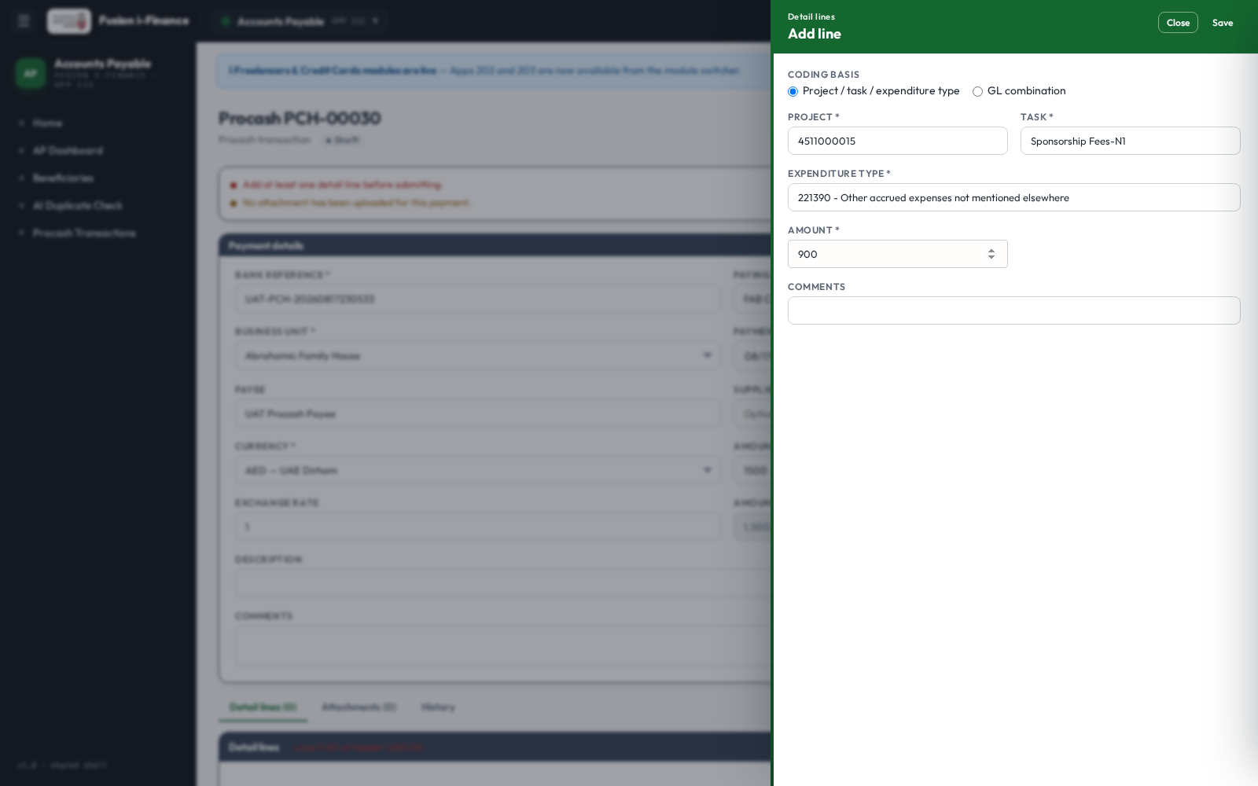

07 · A project line without a task is refused
Area: Budget coding
Steps: Try to save a project-coded line that carries no task.
Expected: The system refuses it (400): a project line needs project, task and expenditure type.
Actual: HTTP 400 returned
Status: PASS

08 · A GL combination outside the chart of accounts is refused
Area: Budget coding
Steps: Try to save a GL-coded line quoting a combination that does not exist.
Expected: The system refuses it (400).
Actual: HTTP 400 returned
Status: PASS

09 · A payment whose lines do not add up cannot be submitted
Area: Lifecycle
Steps: With lines totalling less than the payment amount, choose Submit.
Expected: The payment stays Draft and the difference is reported.
Actual: Status after Submit: draft
Status: PASS
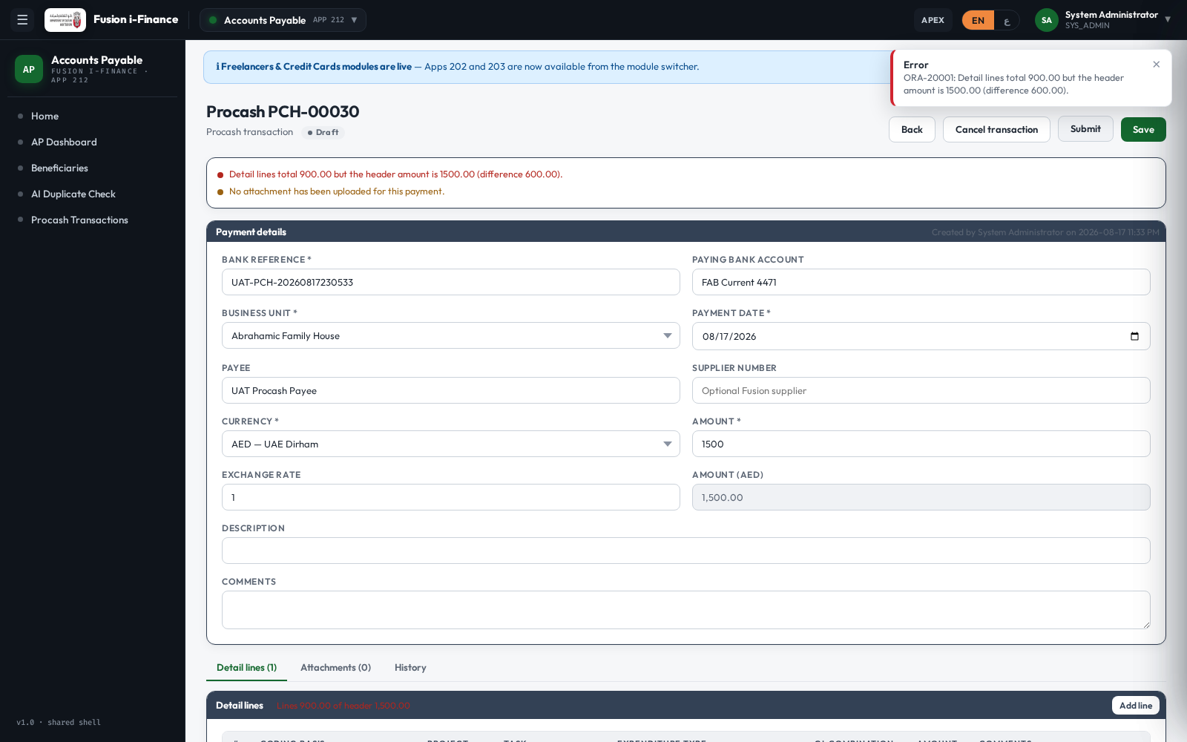

10 · A balanced payment submits
Area: Lifecycle
Steps: Correct the payment amount so it equals the lines, Save, then Submit.
Expected: The payment moves to Submitted.
Actual: Status: submitted
Status: PASS
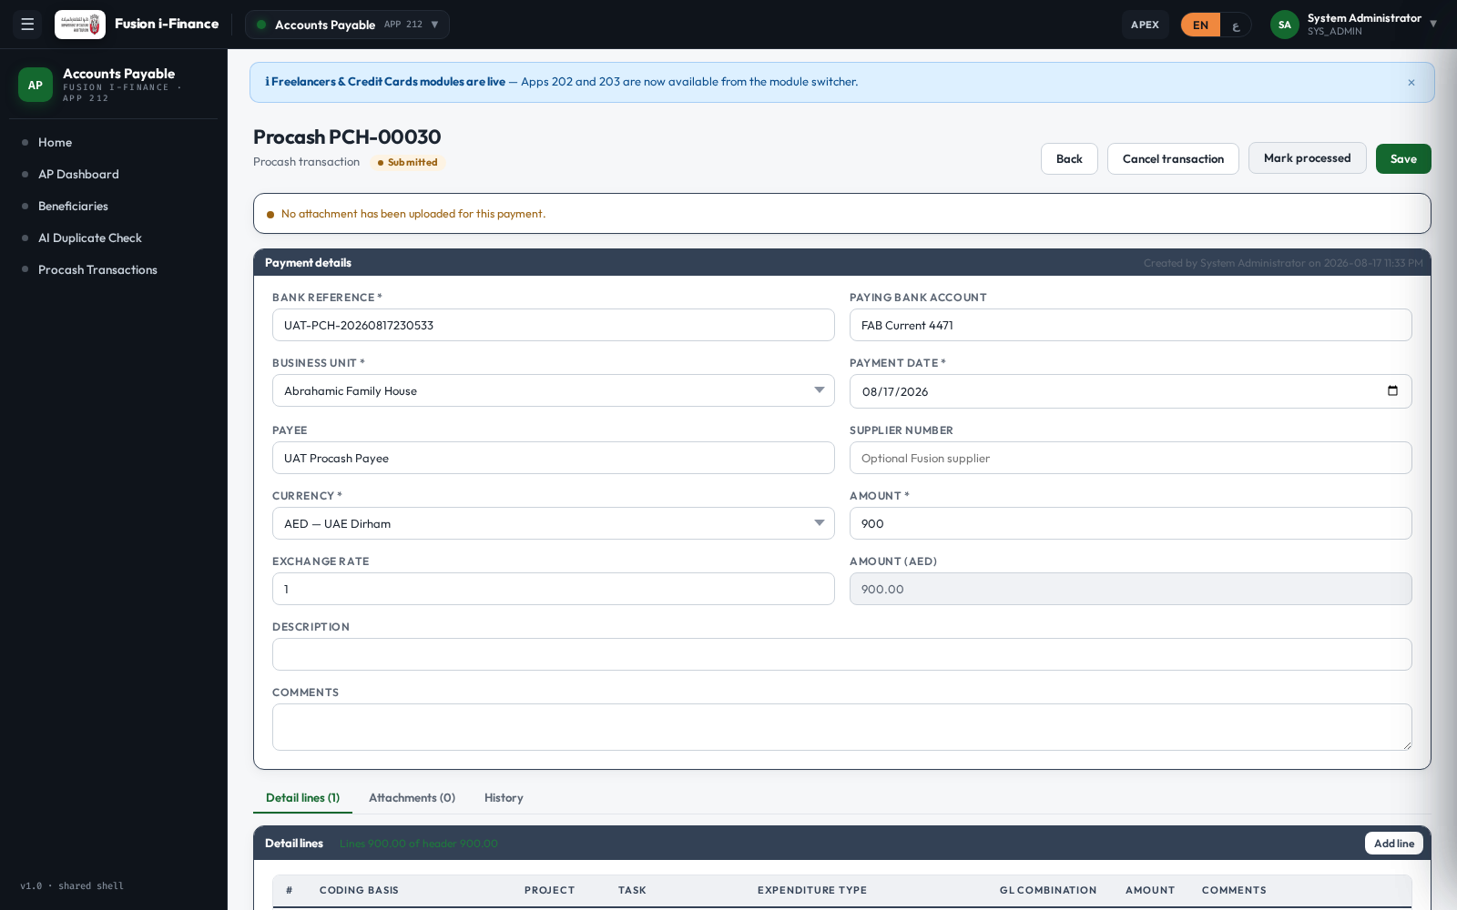

11 · Mark the payment processed once the bank has paid it
Area: Lifecycle
Steps: Choose Mark processed.
Expected: The payment moves to Processed and the system stamps who processed it and when.
Actual: Status processed, processed by "System Administrator" on 2026-08-17 11:33 PM
Status: PASS
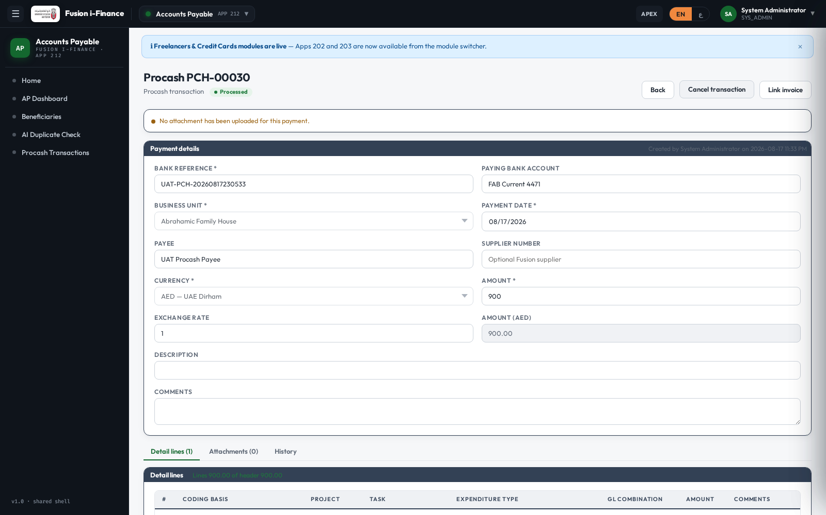

12 · Pick the Fusion payable invoice from the loaded list
Area: Reconciliation
Steps: Choose Link invoice and search the list of Fusion invoices.
Expected: Only invoices already loaded from Fusion are offered, and ones already linked are marked.
Actual: 100 invoice(s) offered
Status: PASS
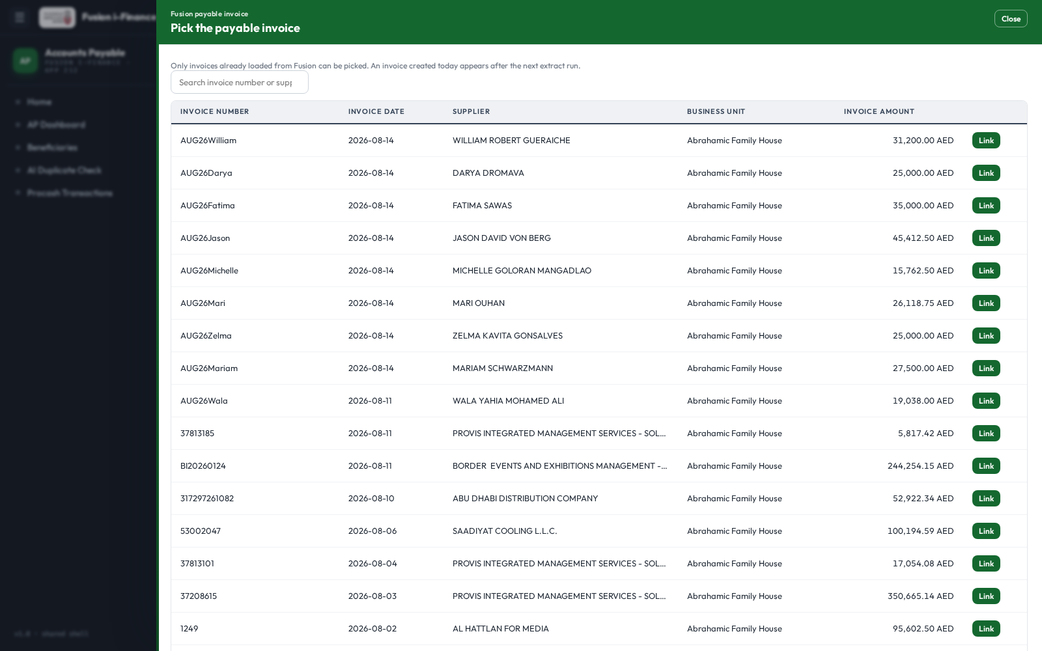

13 · Linking the invoice completes the record
Area: Reconciliation
Steps: Choose Link against one of the offered invoices.
Expected: The payment moves to Invoiced and the invoice number, supplier, date and amount are stored.
Actual: Status invoiced, invoice AUG26William
Status: PASS
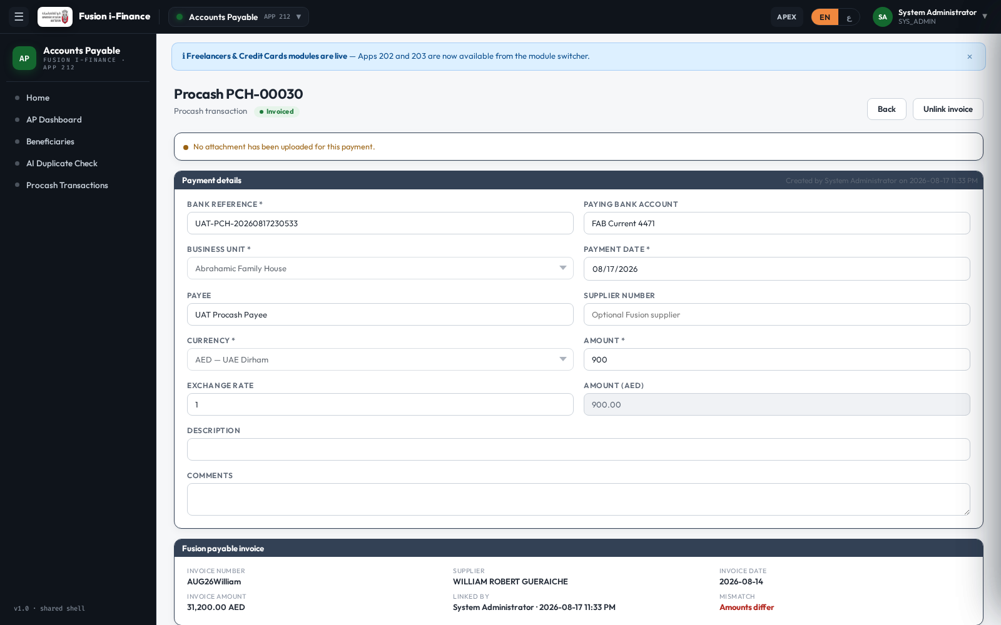

14 · A difference between the payment and the invoice is flagged
Area: Reconciliation
Steps: Read the Fusion payable invoice region.
Expected: The system states whether the amounts agree, so a difference cannot pass unnoticed.
Actual: Mismatch flag = Y (invoice 31200 vs paid 900)
Status: PASS

15 · An invoiced payment can no longer be edited
Area: Controls
Steps: Try to change the payee of an invoiced payment.
Expected: The system refuses it (403).
Actual: HTTP 403 returned
Status: PASS

16 · Every status change is on the record
Area: Audit
Steps: Open the History tab.
Expected: The trail shows each transition with who made it and when.
Actual: 104 history entries
Status: PASS
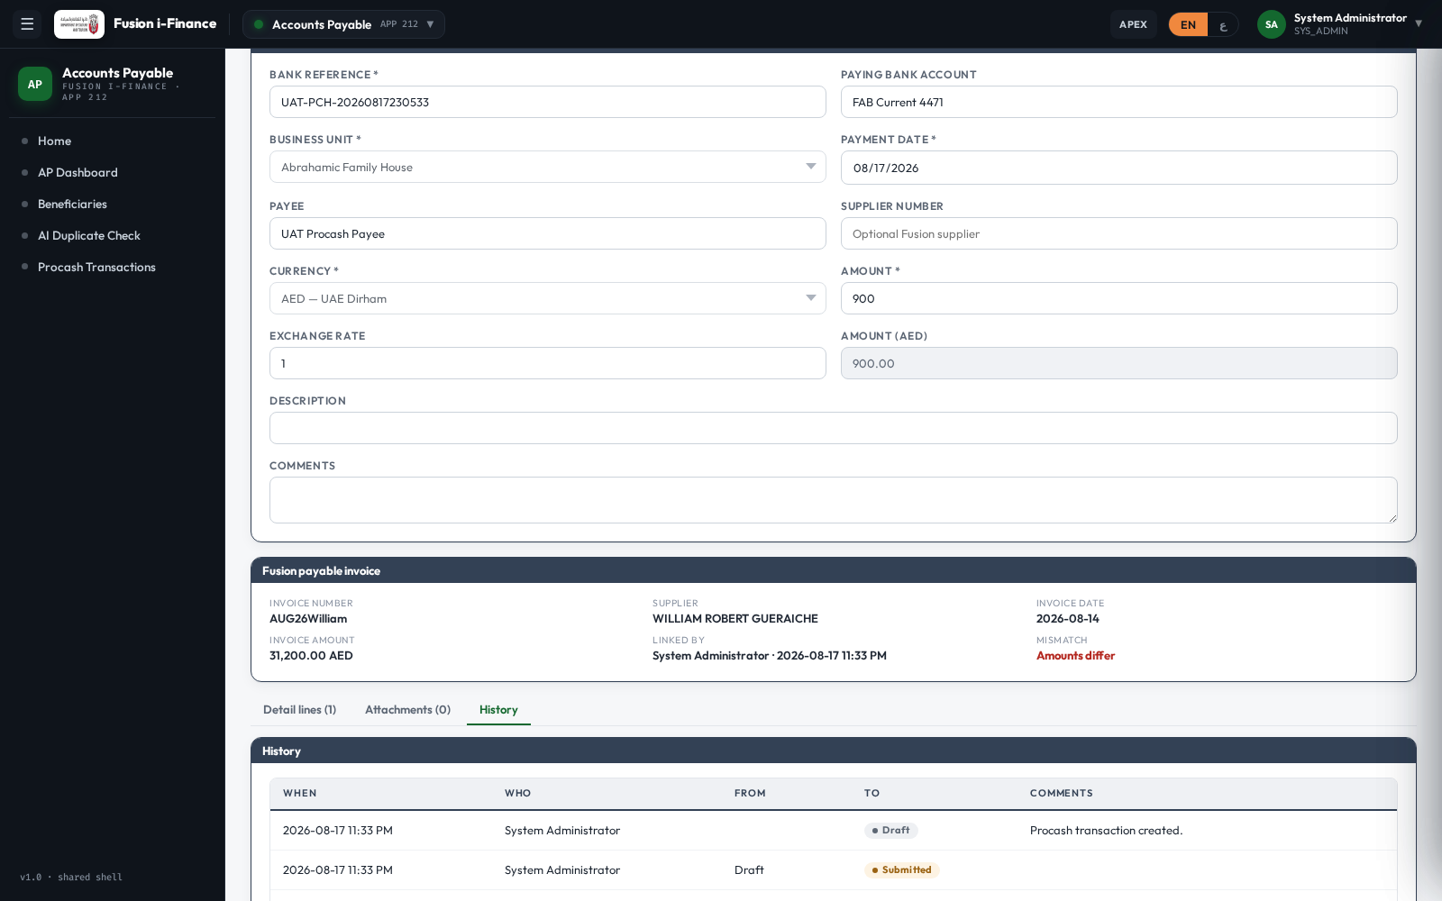

17 · Supporting documents can be attached
Area: Attachments
Steps: Open the Attachments tab.
Expected: The tab offers the document checklist and an upload action.
Actual: Attachment tab rendered with the type picker
Status: PASS
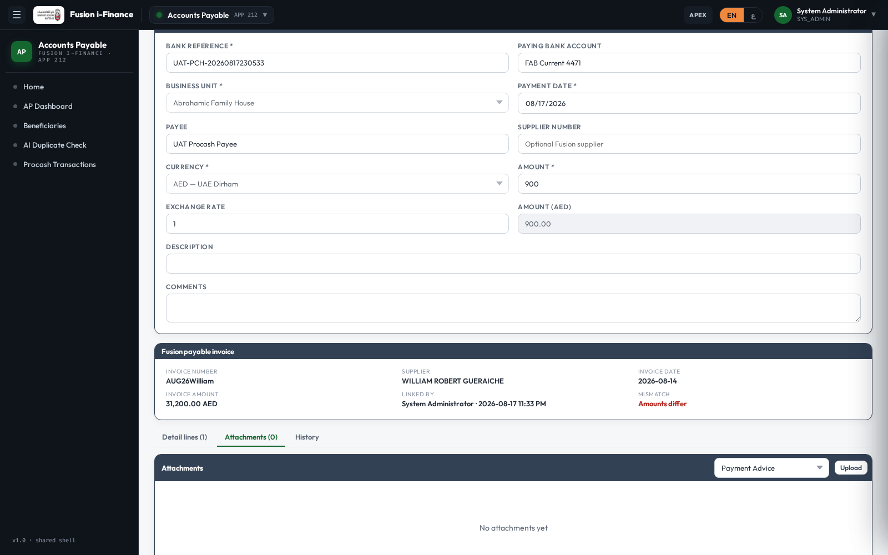

18 · Search and filters narrow the register
Area: Register
Steps: Type the bank reference in the search box.
Expected: Only the matching payment is listed, with its status pill.
Actual: 1 row(s) found
Status: PASS
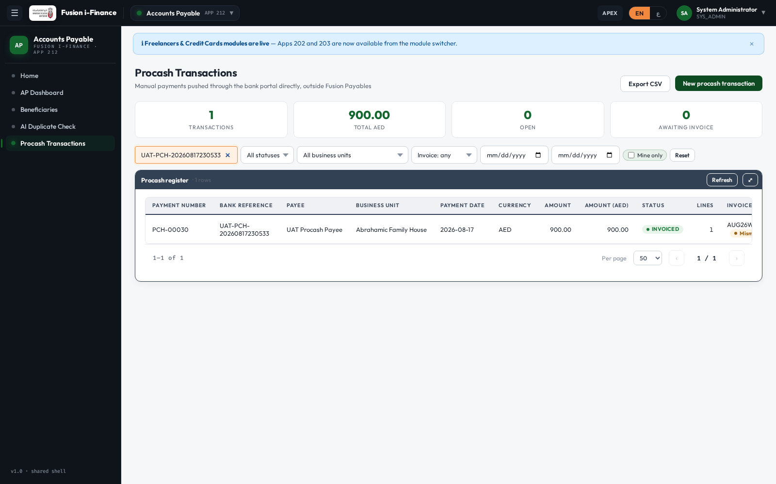

19 · The register can be exported to CSV
Area: Export
Steps: Choose Export CSV on the register page.
Expected: A CSV of the filtered register downloads.
Actual: Export endpoint returned HTTP 200
Status: PASS

20 · Generate the Procash Transactions Register
Area: Reporting
Steps: Run the report for the current filters and wait for it to finish.
Expected: The Reporting Platform produces the register (summary, payments, lines, reconciliation and exceptions).
Actual: Run 543 finished with status SUCCESS
Status: PASS

21 · The page works in Arabic, right to left
Area: Localisation
Steps: Switch the language to Arabic.
Expected: The page mirrors to right-to-left and every label is Arabic.
Actual: dir=rtl, title "معاملات الدفع المباشر"
Status: PASS
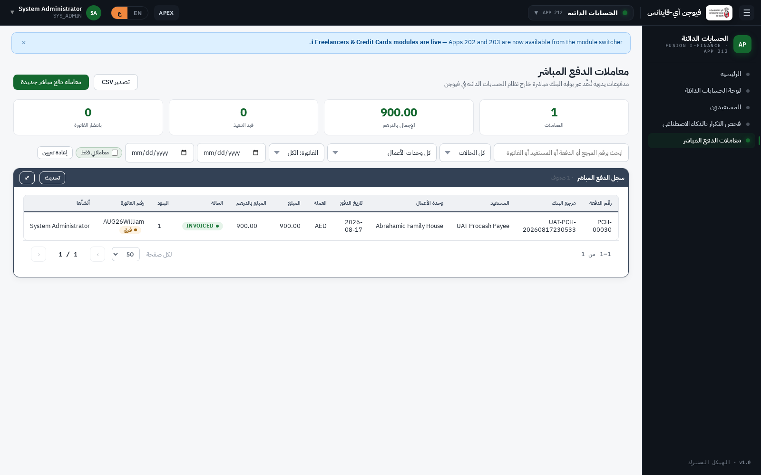

22 · The Excel entry template can be downloaded
Area: Excel
Steps: Download the procash workbook from the template repository.
Expected: The workbook downloads with its Single, Headers, Lines and Invoice Update sheets.
Actual: Template download returned HTTP 200
Status: PASS

